1.Question 1

What is the difference between unintentional and intentional plagiarism?

*Check one option.*



Unintentional plagiarism is when you are not aware of your plagiarism, and intentional plagiarism is when you deliberately copy another’s work.

2.Question 2

Which of the following would you NOT need to reference at university?

*Check 2 options.*



Your own ideas



Common knowledge

3.Question 3

Compare the original with a student’s paraphrase below.

*Original*

“AI systems have already become far too complicated for the average person to understand, let alone repair, so there will be new roles created which will require people who can act as intermediaries between computers and humans.” (Bollegala, D. (2016, May 5). Robot revolution: rise of the intelligent automated workforce. *theconversation.com*. Retrieved from <http://theconversation.com/robot-revolution-rise-of-the-intelligent-automated-workforce-58252>)

*Student’s paraphrase*

The growing use of AI in society does not preclude job growth. There are those that argue that, instead, the use of AI will lead to new forms of employment. For example, because machine learning systems have already become far too complicated for ordinary people to understand or fix, there will be new jobs that will emerge which will require people who can act as mediators between AI systems and humans (Bollegala, 2016).

Has the student plagiarized the original?

*Check one option.*



Yes

1.Question 1

What are the **two** places in academic writing where citations appear and must correspond?

In-text and end-text

2.Question 2

What type of referencing system is being used in the text below?

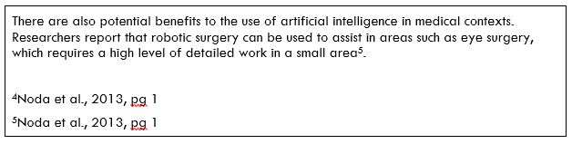



Footnote

3.Question 3

Look at the following in-text citation, using an in-text citing system, in an essay.

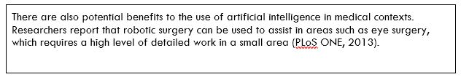

There is an error with the in-text citation. What is the problem?



The writer has given the publication name rather than the author’s name.

1.Question 1

Below is an original quote from the Noda et al. article, and also the direct quote as used in a student’s essay.

*Original quote*

“Recently robot-assisted surgery has broadened its application and has been introduced into the surgical theaters worldwide.” (Noda et al., 2013, p. 1)

*Student’s writing*

Another important innovation has been the advent of robotic surgery, which Noda et al. write has “recently … broadened its application and has been introduced into surgical theaters worldwide” (2013, p. 1).

Has the student used the quote correctly or incorrectly? If it is incorrect, why?

The student’s use of the quote is incorrect because they should have put the ‘r’ in “recently” in square brackets.

2.Question 2

Which of the following is NOT a strategy for paraphrasing suggested by Swales and Feak (2012)?

Rearrange the order of information from the original.

3.Question 3

*Original*

“Recently robot-assisted surgery has broadened its application and has been introduced into the surgical theaters worldwide” (Noda et al., 2013, p. 1).

*Student’s writing*

Some writers, such as Noda et al. (2013), have written that robotic surgery can now be found in many hospitals around the world.

How has the writer modified the claim of the original in their paraphrase?.



Softened the claim.